CCNA4-Lab 2: DHCP
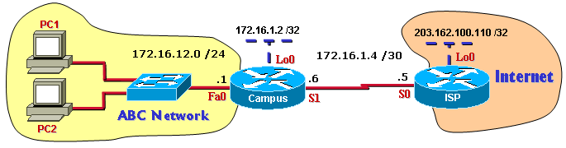

Scenario for DHCP configuration:
In ABC network, the administrator uses DHCP for PCs address configuration. Assume ABC network has DNS Server built at IP address 172.16.1.2 and WINS Server at 172.16.1.10
Part 1: Configuration DHCP
- Basic configuration (hostname, enable and telnet password, …) for each Router.
- Configure ip address, subnetmask, … for each interface on both Routers.
- On ISP router, create a static route to the ABC network (172.16.12.0 and 172.16.1.0)
- On Gateway router, create the default route to Internet.
- Create the DHCP address pool.
Campus(config)# ip dhcp pool campus
Campus(dhcp-config)# network 172.16.12.0 255.255.255.0
Campus(dhcp-config)# default-router 172.16.12.1
Campus(dhcp-config)# dns-server 172.16.1.2
Campus(dhcp-config)# domain-name abc.com
Campus(dhcp-config)# netbios-name-server 172.16.1.10
- Excluding addresses from pool.
Campus(config)# ip dhcp excluded-address 172.16.12.1 172.16.12.10
- Testing the configuration.
    - Obtain IP address for PCs in ABC Network.
    - Ping from PCs to each other and to Internet.
- View DHCP binding: Campus(config)# show ip dhcp binding

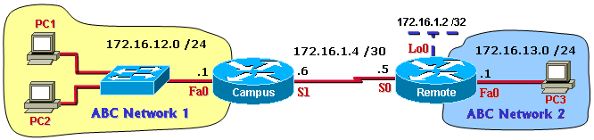
Scenario for DHCP Relay configuration:
In ABC company, the administrator setup DHCP Server on Remote router. At DHCP Server, he creates 2 pool: 172.16.12.0 /24 for hosts on Nework1 and 172.16.13.0 /24 for hosts on Nework2. However, broadcasts are not forwarded by routers, so in the case, the workstations in ABC Network1 will not be able to locate the DHCP server on Remote router. The Campus router must be configured as DHCP Relay to enable forwarding of these broadcasts, as unicast packets, to the specific server.
Part 2: Configuration DHCP Relay
- Basic configuration (hostname, enable and telnet password, …) for each Router.
- Configure ip address, subnetmask, … for each interface on both Routers.
- On both Campus and Remote router, configure the static or any dynamic routing protocol for communication between ABC Network1 and Network2 .
- Create the DHCP address pools on Remote router.
Remote(config)# ip dhcp pool network1
Remote(dhcp-config)# network 172.16.12.0 255.255.255.0
Remote(dhcp-config)# default-router 172.16.12.1
Remote(dhcp-config)# dns-server 172.16.1.2
Remote(dhcp-config)# domain-name abc.com
Remote(dhcp-config)# netbios-name-server 172.16.1.10

Remote(dhcp-config)# ip dhcp pool network2
Remote(dhcp-config)# network 172.16.13.0 255.255.255.0
Remote(dhcp-config)# default-router 172.16.13.1
Remote(dhcp-config)# dns-server 172.16.1.2
Remote(dhcp-config)# domain-name abc.com
Remote(dhcp-config)# netbios-name-server 172.16.1.10
- Excluding addresses from pools on Remote router.
Remote(config)# ip dhcp excluded-address 172.16.12.1 172.16.12.10
Remote(config)# ip dhcp excluded-address 172.16.13.1 172.16.13.10
- Configure DHCP Relay on Campus router.
Campus(config)# interface Fa0
Campus(config-if)# ip helper-address 172.16.1.5
- Testing the configuration.
    - Obtain IP address for PCs in ABC Network1 and ABC Network 2.
    - Ping from PCs to each other.
- View DHCP binding: Remote(config)# show ip dhcp binding

